**SRS**

**TEAM NUMBER: 28**

**ID1: 201501123**

**ID2: 201501128**

**FACT FINDING CHART**

|  |  |  |  |
| --- | --- | --- | --- |
| **OBJECTIVES** | **TECHNIQUES** | **SUBJECT** | **TIME COMMITMENT** |
| To get background of how renting system works? | Background Reading,  Interview | Company reports, surfing online, reading documentations. | .5 day |
| To find out how the core business operates | Interview, Background reading | 1 Account Manager  2.Reading about the business model of established companies | 3-4 hours |
| To establish what records and resources are kept | Interview | Filing Clerk | 1.5 hour |
| To establish accounting requirement for our system | Interview | 1. Chartered Accountant 2. Clerk | 2 hours each |
| Are people interested in giving and taking things on rent? | Questionnaire | Making a google form | 2 days  (including analysing the response) |
| To find out how established renting companies work | Interview, Background Readings | Interviewing People from Established companies, Company reports, surfing online, reading documentations | .5 days |

**Technique 1: Background Reading**

* [https://en.wikipedia.org/wiki/Renting](https://en.wikipedia.org/wiki/Renting.pdf)

From the above website we came to knew what actually a renting system is and to rent services.

* <http://www.ijsrp.org/research-paper-1114/ijsrp-p35101.pdf>

This page provided us the key abstract for this software engineering project. We got enlightened about how to write a documentation on some project along with the necessary

* [https://rowa.de/en/support/pharmacist/what-is-the-advantage-of-renting-the-systems](https://rowa.de/en/support/pharmacist/what-is-the-advantage-of-renting-the-systems.pdf)

From the above link we came to know about what are the advantages of renting and why it should be done in this persistently growing tech world.

* [https://www.olx.co](https://www.olx.com)m

This website was basically our ‘ role model ’ for this project. We got an idea about how we can device a software and construct a website from scratch which will include all the features we mentioned in the description and how to **enhance** our platform.

* [https://www.investopedia.com/financial-edge/1112/reasons-renting-is-better-than-buying.aspx](https://www.investopedia.com/financial-edge/1112/reasons-renting-is-better-than-buying.aspx.pdf)

This link helped us in knowing the fact that why renting is better than buying.

**Technique 2: INTERVIEW/S**

**ZOOM CAR : INTERVIEW PLAN**

**System :** Renting System

**Project Reference :** SF/SJ/2017/12

**Participants**:

Shirish Jain (Renting System)

Ashray Bharambe (Renting System)

Rahul Singh (Zoom Car Worker)

**Date:** 25/1/2018 **Time :** 14:30

**Duration :** 30 minutes **Place:** Mr.Rahul’s Office

**Purpose Of Interview:**

To get a better understanding of how renting system works in real life scenario. What are the challenges they face in renting cars? How do they manage for cars that are rented and get damaged ? How they deal with customers in general ?

**Agenda**:

Problems in dealing with people in general and any other concerns. Current working procedure that they follow in ZOOM car in renting cars. Getting initial ideas to have a good start. Follow-up actions.

**Documents to be brought to the interview** :

Rough plan of building. Any documents relating to their current online woking procedure.

**Technique 3: QUESTIONNAIRE/s**

Questionnaire 1 (For Owner)

**Owner –**  Have you given a thing on rent?

Please circle your answers to the following questions:

1. Do you like to give things on rent? If **NOT,**why?

* Yes
* No

Comments if any :

2. Have you ever rented a thing and faced problems like not receiving money on time ?

* Yes
* No

3. Which of the followings things would you like to give on rent?

(you may tick one or more options)

* House
* Flat
* Car
* Household Goods like washing machine, dishwasher, geyser etc.
* Books
* Clothes
* Furniture

4. Do you like to donate things if they are no more useful to you?

* Yes
* No

5. Would you like to see some more genuine customers/buyers ?

* Yes
* No
* Don’t mind

6. Have you encountered a customer that was not willing to return your things and you faced legal issues ?

* No, I have not rented anything earlier
* Yes, a lot of time
* No, yet I have not faced anything such problem

7. Would you like to have a website where you can meet your demands on a single

Platform?

* Yes
* No

Questionnaire 2 (For Hirer)

**Hirer :**  Survey for goods and things that people might want to hire.

Please tick your answers to the following questions:

1. Are you a frequent traveller or do you keep changing places due to transfers or some unavoidable circumstances?

* Yes
* No

2. Do you like to hire things on rent? If **NOT,**why?

* Yes
* No

**Comments if any:**

3. Which of the followings things would you like to hire on rent?

(you may tick one or more options)

* Bungalow
* Flat
* Car
* Household Goods like washing machine, dishwasher, geyser etc.
* Books
* Clothes
* Furniture

4. Do you face difficulties in finding a skilled technician for your broken goods?

* Yes
* No

5. Have you unknowingly rented a thing that was not in proper working condition?

* No, I have not rented anything earlier
* Yes, I have been handed a faulty thing
* No, yet I have not been handed a faulty thing

6. If you have rented earlier, was paying rent a cumbersome process?

* Yes
* No

7. Would you like to have a website where you can meet your demands on a single

Platform?

* Yes
* No

8. Please do share your experience if you have rented things earlier:

**Comments :**

Questionnaire 3 (For Technician)

**Technician :** Survey for technicians

Please tick your answers to the following questions:

1. Are you currently working with any organisation or not?

* Yes
* No

2. Are you willing to work for a part time or full time job?

* Part time
* Full time

3. Which of the following is your field of specialisation?

* Plumbing
* Electrician
* Mechanic
* Tailor
* Other

Comment :

4. Do you face problems finding work for yourself?

* Yes
* No

5. Are you correctly valued for the work you do?

* Yes
* No

6. Would you like to have a website where you can meet your demands on a single

Platform?

* Yes
* No

**REQUIREMENTS COLLECTION :**

1. Credentials of users like name, address, contact number, email id etc.
2. Soft copy of Government documents to verify the credentials of user.
3. Invoice of the goods people wish to rent.
4. Database to store information of all the users and things on rent.
5. A legal contract between owner and customer for approval of the deal.
6. Chatting platform for users to have convenience in conversation.
7. A GPS software to locate the users and technicians nearby them.
8. A searching functionality for users to search goods as per their wish.
9. Money transfer portal for the users to pay or collect rent.
10. A notification system that reminds user to pay or collect rent after each month.
11. A courier service to collect goods from users and deliver them to people in need.
12. Contacts of NGOs, orphanage homes so as to get the location where the goods need to be donated.
13. A recommendation system for the users where the user will be recommended a technician with the appropriate skill set.
14. A feedback section where people can write to us about problems faced by them or any inconvenience experienced by them while adapting to the software.
15. Secure website so that user’s data is not exploited.
16. Safe and secure gateway for payment.
17. A lawyer to validate the affidavit that confirms the agreement between the hirer and owner.
18. A review system for the goods.
19. A review system for technicians.
20. A review system for users.

**USER CATEGORIES :**

* Hirer

1. Credentials of users like name, address, contact number, email id etc.
2. Soft copy of Government documents to verify the credentials of user.
3. A legal contract between owner and customer for approval of the deal.

* Owner

* Technician

**Responses for Questionnaire**

***Number of people it was sent to: 25***

***Number of people who responded : 16***

Do you like to give things on rent? If NOT, why?

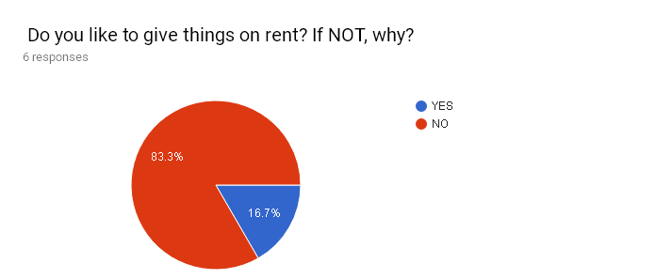

**Response of Open Ended Question:**

1. No, because at present there is no good platform for renting things.
2. No, because of trust issues.
3. Problems in collecting rents.
4. Problems in finding socially ethical & wise users to whom you can rent.

Almost **80 percent** of the people responded that they do not give things on rent.

In the interest of the users being able to make an informed decision we are providing a great renting platform where anyone can rent almost everything and can foresee the user rating. Also we are providing the platform for doing online transactions.

Would you like to have a website where you can meet your demands on a single Platform?

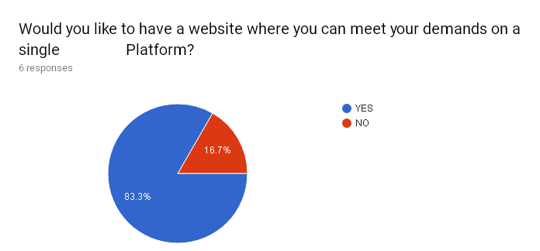

Yes, we are providing that.

Have you ever rented a thing and faced problems like not receiving money on time ? 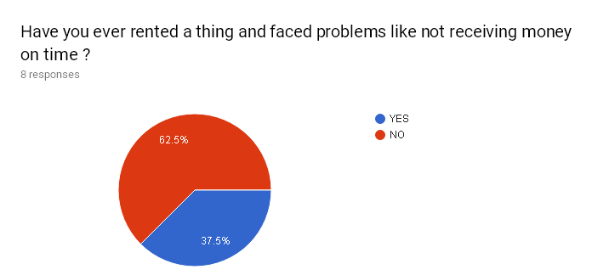Almost **40 percent** of the people responded that they faced such issues.

Which of the followings things would you like to give on rent? (you may tick one or more options)

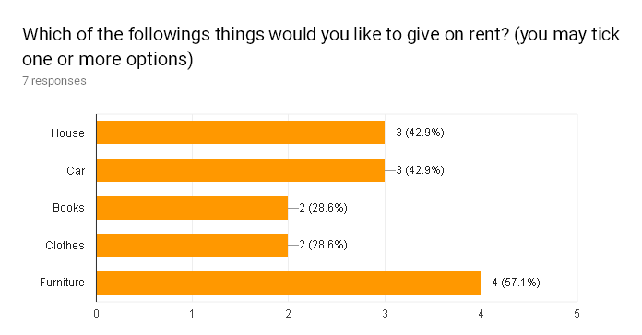

Do you like to donate things if they are no more useful to you?

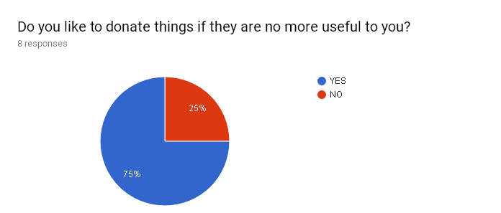

Though most of the people are not interested in donating, still we are having this feature for some generous souls.

Have you encountered a customer that was not willing to return your things and you faced legal issues ?

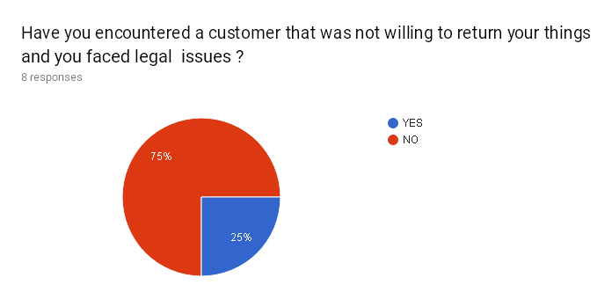

We are providing this security feature by collecting legal documents beforehand.

Have you unknowingly rented a thing that was not in proper working condition?

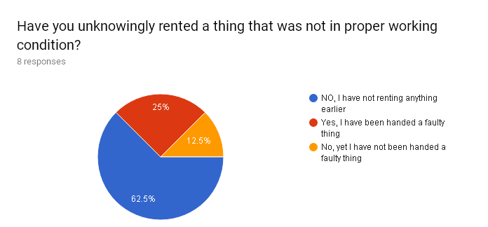

If you have rented earlier, was paying rent a cumbersome process?

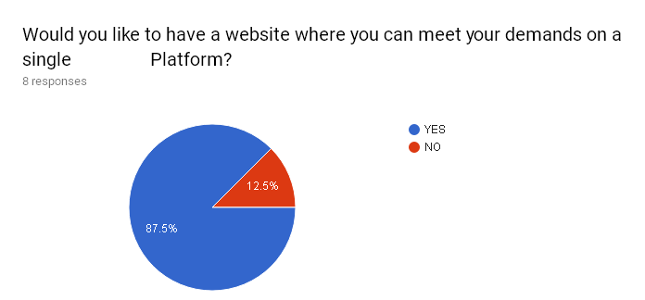

Please do share your experience if you have rented things earlier:

Response:

I have rented earlier and my experience was not good at all. Collecting rent was a difficult process and since i had no legal proof I made a loss.

**INTERVIEW SUMMARY**

**Zoomcar Officer’s** **Interview Summary.**

PARTICIPANT - **MR. RAHUL SINGH** (ZOOMCAR’s Office Manager )

Date: 25/1/2018

Time : 14:30

Duration : 30 minutes

Place: Sargasan Chowkdi - CH 0 (Rahul’s office)

**PURPOSE OF INTERVIEW**-

Understanding how renting system works in real life scenario. What are the challenges they face in renting cars? How do they manage for cars that are rented and get damaged ? How they deal with customers in general ?

1. Some documents are absolutely necessary to carry out the process especially DRIVING LICENCE.
2. All the documents are uploaded and verified within 5 minutes.
3. They keep an advance deposit of 5000 so that in case the customer cheats or do not return car in time, they charge him/her.
4. All the cars they provide are insuranced and thus claiming money is not an issue.
5. Paying rent online is a very good idea as it would lead to more efficient work and people will indulge more into renting.
6. They also show car’s that are nearby and can be given on rent.
7. Provide interactive interface and keep it simple , many features may confuse the users.
8. The current system is complex or rather rigid in layman’s terms. People have to move from one place to other in order to search for houses/cars that they can get on rent.

**INTERVIEW SUMMARY**

**OFFICIAL : DAIICT ELECTRICIAN**

PARTICIPANT - **MR. Ashok** **Gajera**

Date: 26/1/2018

Time : 13:30

Duration : 20 minutes

Place: DAIICT

**PURPOSE OF INTERVIEW** :

Preliminary meeting to identify the problems faced by the technicians in terms of unemployment, getting salaries and so on.

1. Most of the times it happens that they don’t have work to do, that is, they are idle which results into inefficient utilisation of their work time.
2. They are also not receiving salaries up to their expectations.
3. They try to look for work outside campus but it becomes very difficult for them to find the appropriate work.
4. They would be very much interested in a platform where they could instantly find some part-time work, which in turn will lead to an increase in their wage on daily basis.

***Assumptions and Dependencies***

.

* It is assumed that all the Users (Hirer and Owner) can access the system through internet.
* Technician can also access the system through internet.
* People have Aadhar card/ some legal document for proof.
* The owners know how to put their information on website.
* Users scan the documents and upload the same.
* Users should know basic english.